Project Title: Automobile Sales Performance & Customer Insights Dashboard
Project Overview
This project focuses on analyzing an automobile sales dataset to understand sales performance, product trends, and customer behavior using Power BI.
The objective of the project is to:
• Analyze overall sales performance and revenue trends over time.
• Evaluate product line performance and identify top-performing products.
• Understand customer behavior, including repeat purchases and customer segmentation.
• Identify key business insights such as revenue concentration and customer retention.
• Present insights through interactive dashboards for better decision-making.
Tools Used:
• Power BI (Data Visualization & Dashboarding)
• Power Query (Data Cleaning & Transformation)
• DAX (Data Analysis Expressions for KPIs & Measures)

Dataset Overview
The dataset consists of automobile sales transaction data representing the operations of a retail automobile company. It contains detailed information about orders, customers, products, and sales performance.
The dataset includes the following key components:
• Order Information – includes order number, order date, and order status, which help in analyzing sales trends over time.
• Sales Details – contains quantity ordered, price per item, and total sales value, enabling revenue and performance analysis.
• Customer Information – includes customer name, city, and country, which are used to understand customer distribution and behavior.
• Product Information – includes product line, product code, and MSRP, allowing analysis of product performance and pricing.
• Customer Behavior Metrics – includes days since last order, which is used to analyze customer retention, recency, and segmentation.
• A composite key (Order Number + Order Line Number) was used to uniquely identify each transaction.

Data Preparation & Modeling
The dataset was cleaned and transformed using Power Query:
• Irrelevant columns such as contact details and address fields were removed to improve analysis efficiency.
• Data types were corrected for numerical and date fields.
• New columns such as Year, Month, and Month Number were created for time-based analysis.
• Customer segmentation was performed using recency logic based on days since last order.
Since the dataset is a single-table structure, no relationships were required, and analysis was performed using calculated columns and DAX measures.

Data Exploration & Cleaning
Initial exploration of the dataset was performed in Power BI to understand the structure and quality of data. This included:
• Checking overall data consistency and column distributions
• Identifying missing or null values, particularly in customer-related fields
• Validating date ranges and numerical fields such as sales, quantity, and price
Data cleaning steps were carried out using Power Query:
• Irrelevant columns such as contact details and address fields were removed to reduce redundancy
• Data types were standardized (dates, numerical fields, and categorical variables)
• Missing values in key fields were reviewed and handled appropriately
• Date-based columns were prepared for time-series analysis
Feature Engineering
To enable deeper analysis and derive meaningful insights, several calculated columns and measures were created using DAX:
Time-Based Features
• Year – extracted from order date for yearly analysis
• Month – used for monthly trend analysis
• Month Number – created for correct chronological sorting
Segmentation
• Customer Type – customers were classified based on recency (days since last order) into categories such as Active, Inactive/At Risk
👉 This helped in analyzing customer retention and lifecycle behavior
Key Business Metrics (DAX Measures)
• Total Sales – total revenue generated
• Total Orders – number of unique orders
• Total Customers – number of distinct customers
• Average Order Value (AOV) – average revenue per order
Advanced Customer Metrics
• Sales per Customer – average revenue generated per customer
• Repeat Customers – number of customers with multiple purchases
• Top 5 Customer Contribution (%) – percentage of revenue contributed by top customers
• Purchase Gap (Average Days Between Purchases) – measures customer buying frequency
Note on Data Limitations
The dataset contains historical data and does not include recent transactions. As a result, customer recency-based segmentation (e.g., churn or at-risk classification) was adjusted using relative date logic to ensure meaningful distribution.

Analysis & Key Insights
To provide a comprehensive analysis of the automobile sales data, a multi-page interactive dashboard was developed using Power BI. The dashboard is structured into three dedicated pages, each focusing on a specific business aspect:
• Sales Overview – to analyze overall business performance, revenue trends, and key sales drivers.
• Product Performance – to evaluate product-level insights, identify top-performing products, and understand revenue contribution by product categories.
• Customer Insights – to examine customer behavior, retention patterns, and revenue contribution from different customer segments.
This structured, page-wise approach enables a deeper and more focused analysis of each business dimension, allowing stakeholders to gain clear insights and make data-driven decisions more effectively.
Page 1: Sales Overview Dashboard
The Sales Overview dashboard provides a high-level view of business performance by tracking key revenue metrics and trends.
- Overall Performance
Key performance indicators such as Total Sales, Total Orders, Total Customers, and Average Order Value (AOV) were used to evaluate overall business performance.
These metrics help in understanding both revenue generation and customer purchasing behavior.
- Sales Trend Analysis
Sales were analyzed over time using monthly trends to identify seasonality and fluctuations in demand.
The trend indicates periods of increased sales activity, suggesting potential seasonal demand patterns or promotional impacts.
- Revenue Distribution by Product Line
Sales contribution across different product lines was analyzed to identify key revenue drivers.
A few product lines contribute a significantly higher share of total revenue, indicating concentration in specific categories.
- Geographical Performance
Sales distribution by country highlights key markets contributing to overall revenue.
Certain regions dominate sales, suggesting strong market presence and potential opportunities for regional expansion.
- Deal Size Contribution
Revenue was segmented by deal size (Small, Medium, Large) to understand transaction value distribution.
Larger deals contribute a substantial portion of total revenue, indicating that high-value transactions are critical for business growth.
Key Insight:
Overall sales performance is driven by a combination of high-value deals and strong-performing product lines, with noticeable variation across time and regions. This suggests opportunities to optimize sales strategies by focusing on high-performing segments and peak periods.
Page 2: Product Performance Dashboard
The Product Performance dashboard focuses on evaluating how different products and categories contribute to revenue and overall business success.
- Product Line Performance
Revenue was analyzed across product lines to identify top-performing categories.
Certain product lines consistently generate higher sales, indicating strong demand and market preference.
- Top Products by Revenue
The top-performing products were identified based on total sales contribution.
A small subset of products contributes a disproportionately high share of revenue, highlighting product concentration.
- Quantity vs Revenue Analysis
The relationship between quantity ordered and total sales was examined to understand demand patterns.
Some products generate high revenue despite lower quantities, suggesting premium pricing or higher unit value.
- Pricing Insights (MSRP vs Sales)
Comparison between MSRP and actual sales values provided insights into pricing effectiveness and revenue realization.
Variations indicate potential pricing strategies or discounting patterns across products.
Key Insight:
Revenue is highly concentrated among specific product lines and top-performing products. High-value products play a significant role in revenue generation, suggesting the need to focus on optimizing product mix and pricing strategies.
Page 3: Customer Insights Dashboard
The Customer Insights dashboard provides a deeper understanding of customer behavior, retention, and revenue contribution.
- Customer Base and Repeat Behavior
Total Customers and Repeat Customers were analyzed to evaluate customer retention.
A significant proportion of customers are repeat buyers, indicating consistent engagement and loyalty.
- Customer Acquisition Trends
New customers were tracked over time to understand growth in the customer base.
Variations in new customer acquisition highlight periods of growth and stagnation.
- Revenue per Customer
Sales per Customer metric was used to measure customer value.
This helps identify high-value customers contributing significantly to revenue.
- Revenue Concentration (Top Customers)
The contribution of top customers (Top 5 %) was analyzed to assess dependency risk.
A small group of customers contributes a large share of total revenue, indicating high revenue concentration.
- Customer Purchase Behavior
Metrics such as average purchase gap were used to understand how frequently customers make purchases.
This helps identify customer buying cycles and engagement levels.
- Customer Segmentation (Recency-Based)
Customers were segmented based on days since last order to identify active, inactive, and at-risk customers.
Due to the historical nature of the dataset, segmentation was adjusted using relative date logic for meaningful classification.
Key Insight:
The business is highly dependent on a smaller group of high-value and repeat customers. Customer purchase patterns indicate opportunities to improve retention and increase engagement through targeted strategies.
Visualizations
The following Dashboards were created in PowerBI after transforming and analysis the data through Power Query and DAX:
Page 1: Sales Overview Dashboard
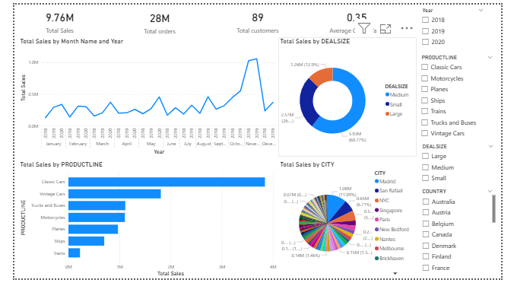
Page 2: Product Performance Dashboard
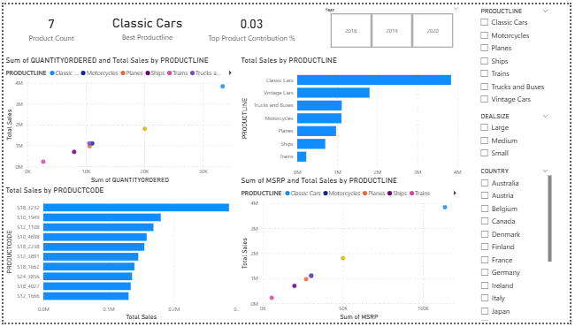
Page 3: Customer Analysis Dashboard
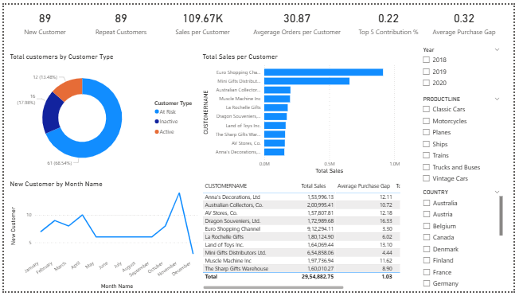
These visuals helped convert insights into easy-to-understand business stories.

Business Recommendations
Sales Strategy Recommendations
• Since sales are concentrated in specific regions and product segments, the business should focus on strengthening its presence in high-performing markets while identifying opportunities to expand in underperforming regions through targeted marketing and localized strategies.
• As sales trends show fluctuations over time, indicating possible seasonal patterns, the company should align promotional campaigns and inventory planning with peak demand periods to maximize revenue.
• Given that large deal sizes contribute a significant portion of total revenue, the business should encourage high-value transactions by offering bundled deals, volume discounts, or incentives for bulk purchases.
Product Strategy Recommendations
• As a limited number of product lines contribute a major share of total revenue, the business should prioritize these high-performing product categories by ensuring better visibility, stock availability, and promotional focus.
• Since some products generate high revenue despite lower quantities, indicating premium pricing impact, the company should explore expanding similar high-margin products to improve profitability.
• For low-performing products with minimal contribution to revenue, the business should evaluate whether to improve pricing, reposition them in the market, or discontinue them to optimize the product portfolio.
• Based on the variation between MSRP and actual sales values, pricing strategies should be reviewed to ensure optimal balance between competitiveness and profitability.

Customer Strategy Recommendations
• Since a small group of customers contributes a significant portion of total revenue (high revenue concentration), the business should reduce dependency risk by acquiring new customers and diversifying its customer base.
• Given the presence of repeat customers contributing consistently to sales, the company should implement loyalty programs, personalized offers, and engagement strategies to further strengthen customer retention.
• As customer purchase patterns indicate gaps between transactions, targeted remarketing campaigns (e.g., email reminders, discounts) should be used to reduce purchase intervals and increase buying frequency.
• Based on customer segmentation using recency, the business should focus on re-engaging inactive or at-risk customers through timely follow-ups and tailored incentives.
• Since customer value varies significantly (Sales per Customer), high-value customers should be identified and targeted with premium services, exclusive offers, or priority support to maximize lifetime value.
Conclusion
This project performed an end-to-end analysis of automobile sales data using Power BI, focusing on sales performance, product insights, and customer behavior. An interactive dashboard was developed using Power Query and DAX to enable clear and effective analysis.
The findings highlight that revenue is driven by a few key product lines and high-value customers, indicating opportunities for growth as well as potential dependency risks. Customer analysis also emphasized the importance of repeat customers and retention strategies.
Overall, the project demonstrates how data visualization and analytics can be used to derive meaningful insights and support better business decision-making.

